Leadership and Management

Leadership is a process that is similar to management in many ways. Leadership
involves influence, as does management. Leadership entails working
with people, which management entails as well. Leadership is concerned
with effective goal accomplishment, and so is management. In general, many
of the functions of management are activities that are consistent with the
definition of leadership we set forth at the beginning of this chapter.
But leadership is also different from management. Whereas the study of
leadership can be traced back to Aristotle, management emerged around the
turn of the 20th century with the advent of our industrialized society. Management
was created as a way to reduce chaos in organizations, to make
them run more effectively and efficiently. The primary functions of management,
as first identified by Fayol (1916), were planning, organizing, staffing,
and controlling. These functions are still representative of the field of management
today.
In a book that compared the functions of management with the functions of
leadership, Kotter (1990) argued that the functions of the two are quite dissimilar
(Figure 1.2). The overriding function of management is to provide
order and consistency to organizations, whereas the primary function of
leadership is to produce change and movement. Management is about seeking
order and stability; leadership is about seeking adaptive and constructive
change.
As illustrated in Figure 1.2, the major activities of management are played
out differently than the activities of leadership. Although they are different
in scope, Kotter (1990, pp. 7–8) contended that both management and leadership
are essential if an organization is to prosper. For example, if an organization
has strong management without leadership, the outcome can be
stifling and bureaucratic. Conversely, if an organization has strong leadership
without management, the outcome can be meaningless or misdirected
change for change’s sake. To be effective, organizations need to nourish both
competent management and skilled leadership.
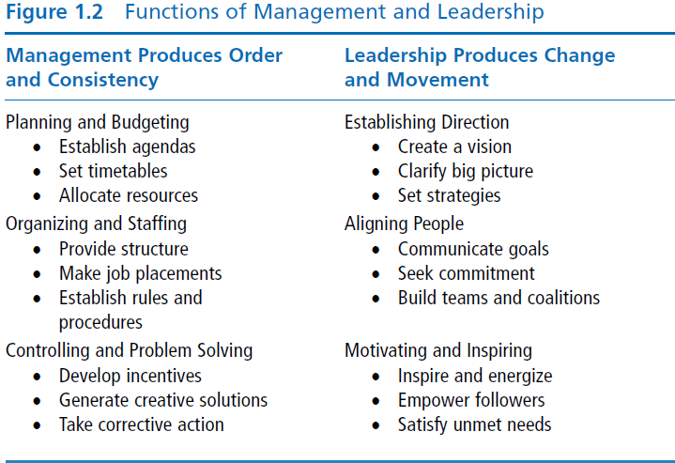
Many scholars, in addition to Kotter (1990), argue that leadership and management
are distinct constructs. For example, Bennis and Nanus (1985)
maintained that there is a significant difference between the two. To manage
means to accomplish activities and master routines, whereas to lead means to
influence others and create visions for change. Bennis and Nanus made the
distinction very clear in their frequently quoted sentence, “Managers are
people who do things right and leaders are people who do the right thing”
(p. 221).
Rost (1991) has also been a proponent of distinguishing between leadership
and management. He contended that leadership is a multidirectional influence
relationship and management is a unidirectional authority relationship.
Whereas leadership is concerned with the process of developing mutual purposes,
management is directed toward coordinating activities in order to get
a job done. Leaders and followers work together to create real change,
whereas managers and subordinates join forces to sell goods and services
(Rost, 1991, pp. 149–152).
In a recent study, Simonet and Tett (2012) explored how leadership and
management are best conceptualized by having 43 experts identify the overlap
and differences between leadership and management in regard to 63
different competencies. They found a large number of competencies (22)
descriptive of both leadership and management (e.g., productivity, customer
focus, professionalism, and goal setting), but they also found several unique
descriptors for each. Specifically, they found leadership was distinguished by
motivating intrinsically, creative thinking, strategic planning, tolerance of
ambiguity, and being able to read people, and management was distinguished
by rule orientation, short-term planning, motivating extrinsically, orderliness,
safety concerns, and timeliness.
Approaching the issue from a narrower viewpoint, Zaleznik (1977) went so
far as to argue that leaders and managers themselves are distinct, and that
they are basically different types of people. He contended that managers are
reactive and prefer to work with people to solve problems but do so with low
emotional involvement. They act to limit choices. Zaleznik suggested that
leaders, on the other hand, are emotionally active and involved. They seek to
shape ideas instead of responding to them and act to expand the available
options to solve long-standing problems. Leaders change the way people
think about what is possible.
Although there are clear differences between management and leadership,
the two constructs overlap. When managers are involved in influencing a
group to meet its goals, they are involved in leadership. When leaders are
involved in planning, organizing, staffing, and controlling, they are involved
in management. Both processes involve influencing a group of individuals
toward goal attainment. For purposes of our discussion in this book, we
focus on the leadership process. In our examples and case studies, we treat
the roles of managers and leaders similarly and do not emphasize the differences
between them.

