Corporate Finance, 4e, Global Edition (Berk / DeMarzo)
Chapter 17 Payout Policy

17.1 Distributions to Shareholders

1) The date on which the board authorizes the dividend is the:
A) declaration date.
B) distribution date.
C) record date.
D) ex-dividend date.

2) The firm will pay the dividend to all shareholders who are registered owners on a specific date, set by the board, called the:
A) declaration date.
B) record date.
C) distribution date.
D) ex-dividend date.

3) Anyone who purchases the stock on or after the ________ date will not receive the dividend.
A) distribution
B) record
C) ex-dividend
D) declaration

4) The firm mails dividend checks to the registered shareholders on the:
A) ex-dividend date.
B) declaration date.
C) distribution date.
D) record date.

5) Which of the following statements is FALSE?
A) From an accounting perspective, dividends generally reduce the firm's current (or accumulated) retained earnings.
B) The way a firm chooses between paying dividends and retaining earnings is referred to as its payout policy.
C) Most companies that pay dividends pay them semiannually.
D) Occasionally, a firm may pay a one-time, special dividend that is usually much larger than a regular dividend.

6) A firm can repurchase shares through a(n) ________ in which it offers to buy shares at a prespecified price during a short time period—generally within 20 days.
A) tender offer
B) open market share repurchases
C) targeted repurchase
D) Dutch auction share repurchase

7) A method to repurchase shares is the ________, in which the firm lists different prices at which it is prepared to buy shares, and shareholders in turn indicate how many shares they are willing to sell at each price.
A) tender offer
B) Dutch auction share repurchase
C) targeted repurchase
D) open market share repurchases

8) A(n) ________ may occur if a major shareholder desires to sell a large number of shares but the market for the shares is not sufficiently liquid to sustain such a large sale without severely affecting the price.
A) open market share repurchases
B) Dutch auction share repurchase
C) tender offer
D) targeted repurchase

9) A(n) ________ is the most common way that firms repurchase shares.
A) targeted repurchase
B) Dutch auction share repurchase
C) tender offer
D) open market share repurchases

17.2 Comparison of Dividends and Share Repurchases

1) Taggart Transcontinental has announced a $2 dividend. If Taggart's last price cum-dividend is $45, then, assuming perfect capital markets, what should its first ex-dividend price be?
A) $0
B) $2
C) $43
D) $45

Use the following information to answer the question(s) below.
Wyatt Oil has assets with a market value of $600 million, $70 million of which are cash. It has debt of $250 million, and 20 million shares outstanding. Assume perfect capital markets.

2) Wyatt Oil's current stock price is closest to:
A) $11.00
B) $12.50
C) $14.00
D) $17.50

3) If Wyatt Oil distributes the $70 million as a dividend, then its stock price after the dividend will be closest to:
A) $12.50
B) $14.00
C) $17.50
D) $26.50

4) If Wyatt Oil distributes the $70 million as a share repurchase, then its stock price after the share repurchase will be closest to:
A) $11.00
B) $12.50
C) $14.00
D) $17.50

5) If Wyatt Oil distributes the $70 million as a share repurchase, then the number of shares outstanding after the repurchase will be closest to:
A) 16.0 million
B) 16.5 million
C) 17.5 million
D) 18.0 million

6) If Wyatt Oil distributes the $70 million as a dividend, then its debt-to-equity ratio after the dividend will be closest to:
A) 0.7
B) 0.9
C) 1.0
D) 1.1

7) If Wyatt Oil distributes the $70 million as a share repurchase, then its debt-to-equity ratio after the share repurchase will be closest to:
A) 0.9
B) 1.0
C) 1.1
D) 1.4

8) Which of the following statements is FALSE?
A) In perfect capital markets, holding fixed the investment policy of a firm, the firm's choice of dividend policy is irrelevant and does not affect the initial share price.
B) In a perfect capital market, when a dividend is paid, the share price drops by the amount of the dividend when the stock begins to trade ex-dividend.
C) In perfect capital markets, an open market share repurchase has no effect on the stock price, and the stock price is the same as the ex-dividend price if a dividend were paid instead.
D) In perfect capital markets, investors are indifferent between the firm distributing funds via dividends or share repurchases. By reinvesting dividends or selling shares, they can replicate either payout method on their own.
Use the information for the question(s) below.
Omicron Technologies has $50 million in excess cash and no debt. The firm expects to generate additional free cash flows of $40 million per year in subsequent years and will pay out these future free cash flows as regular dividends. Omicrons unlevered cost of capital is 10% and there are 10 million shares outstanding. Omicron's board is meeting to decide whether to pay out its $50 million in excess cash as a special dividend or to use it to repurchase shares of the firm's stock.

9) Omicron's enterprise value is closest to:
A) $500 million
B) $900 million
C) $450 million
D) $400 million

10) Including its cash, Omicron's total market value is closest to:
A) $500 million
B) $900 million
C) $400 million
D) $450 million

17.3 The Tax Disadvantage of Dividends

Use the following information to answer the question(s) below.
Year(s) | Capital Gains | Dividends
1987 | 28% | 39%
1988 - 1990 | 28% | 28%
1991 - 1992 | 28% | 31%
1993 - 1996 | 28% | 40%
1997 - 2000 | 20% | 40%
2001 - 2002 | 20% | 39%
2003 - 2009 | 15% | 15%

1) In which years were dividends tax disadvantaged?
A) 1987 - 2002
B) 1987, 1993 - 2002
C) 1987, 1991 - 2002
D) 1988 - 1990, 2003 - 2009

2) In which years were dividends NOT tax disadvantaged?
A) 1987 - 2002
B) 1987, 1993 - 2002
C) 1987, 1991 - 2002
D) 1988 - 1990, 2003 - 2009

3) Which of the following statements is FALSE?
A) Unlike with capital structure, taxes are not an important market imperfection that influence a firm's decision to pay dividends or repurchase shares.
B) If dividends are taxed at a higher rate than capital gains, which has been true until the most recent change to the tax code, shareholders will prefer share repurchases to dividends.
C) Shareholders typically must pay taxes on the dividends they receive. They must also pay capital gains taxes when they sell their shares.
D) Because long-term investors can defer the capital gains tax until they sell, there is still a tax advantage for share repurchases over dividends.

4) Which of the following statements is FALSE?
A) When a firm pays a dividend, shareholders are taxed according to the dividend tax rate. If the firm repurchases shares instead, and shareholders sell shares to create a homemade dividend, the homemade dividend will be taxed according to the capital gains tax rate.
B) When the tax rate on dividends exceeds the tax rate on capital gains, shareholders will pay lower taxes if a firm uses share repurchases for all payouts rather than dividends.
C) Firms that use dividends will have to pay a lower after-tax return to offer their investors the same pre-tax return as firms that use share repurchases.
D) The optimal dividend policy when the dividend tax rate exceeds the capital gain tax rate is to pay no dividends at all.

5) Which of the following statements is FALSE?
A) While firms do still pay dividends, substantial evidence shows that many firms have recognized their tax disadvantage.
B) The fact that firms continue to issue dividends despite their tax disadvantage is often referred to as the dividend puzzle.
C) At the end of the 1990s, dividend payments exceeded the value of repurchases for U.S. industrial firms.
D) While evidence is indicative of the growing importance of share repurchases as a part of firms' payout policies, it also shows that dividends remain a key form of payouts to shareholders.

Use the information for the question(s) below.
The JRN Corporation will pay a constant dividend of $3 per share, per year, in perpetuity. Assume that all investors pay a 20% tax on dividends and that there is no capital gains tax. The cost of capital for investing in JRN stock is 12%.

6) The price of a share of JRN's stock is closest to:
A) $20.00
B) $24.00
C) $25.00
D) $18.00

7) Assume that management makes a surprise announcement that JRN will no longer pay dividends but will use the cash to repurchase stock instead. The price of a share of JRN's stock is now closest to:
A) $20.00
B) $25.00
C) $18.00
D) $24.00
17.4 Dividend Capture and Tax Clienteles

Use the following information to answer the question(s) below.
Year(s) | Capital Gains | Dividends
1987 | 28% | 39%
1988 - 1990 | 28% | 28%
1991 - 1992 | 28% | 31%
1993 - 1996 | 28% | 40%
1997 - 2000 | 20% | 40%
2001 - 2002 | 20% | 39%
2003 - 2009 | 15% | 15%

1) The effective dividend tax rate in 1989 is closest to:
A) 0%
B) 20%
C) 25%
D) 30%

2) The effective dividend tax rate in 1999 is closest to:
A) 0%
B) 20%
C) 25%
D) 30%

3) Wyatt Oil pays a regular dividend of $2.50 per share. Typically the stock price drops by $2.00 per share when the stock goes ex-dividend. Suppose the capital gains tax rate is 20%, but investors pay different tax rates on dividends. Absent transactions cost, the highest dividend tax rate of an investor who could gain from trading to capture the dividend is closest to:
A) 0%
B) 20%
C) 24%
D) 36%

Use the following information to answer the question(s) below.
Suppose that all capital gains are taxed at a 20% rate, and that the dividend tax rate is 40%. Rearden Metal is currently trading for $40 per share, and is about to pay a $5 special dividend.

4) Absent any other trading frictions or news, Rearden's share price just after the dividend is paid will be closest to:
A) $35
B) $36
C) $37
D) $40

5) The effective dividend tax rate for an investor in Rearden Metal is closest to:
A) 0%
B) 20%
C) 25%
D) 30%

6) Suppose that Rearden Metal made a surprise announcement that it would do a share repurchase rather than pay a special dividend, the net tax savings per share for an investor that would result from this decision is closest to:
A) $1.25
B) $3.75
C) $4.00
D) $5.00

7) Which of the following statements is FALSE?
A) Tax rates vary by income, by jurisdiction, and by whether the stock is held in a retirement account. Because of these differences, firms may attract different groups of investors depending on their dividend policy.
B) While many investors have a tax preference for share repurchases rather than dividends, the strength of that preference depends on the difference between the dividend tax rate and the capital gains tax rate that they face.
C) Long-term investors are more heavily taxed on capital gains, so they would prefer dividend payments to share repurchases.
D) One-year investors, pension funds, and other non-taxed investors have no tax preference for share repurchases over dividends, they would prefer a payout policy that most closely matches their cash needs.

8) Which of the following statements is FALSE?
A) Individuals in the highest tax brackets have a preference for stocks that pay high dividends, whereas tax-free investors and corporations have a preference for stocks with no or low dividends.
B) To compare investor preferences, we must quantify the combined effects of dividend and capital gains taxes to determine an effective dividend tax rate for an investor.
C) The dividend-capture theory states that absent transaction costs, investors can trade shares at the time of the dividend so that non-taxed investors receive the dividend.
D) Differences in tax preferences create clientele effects, in which the dividend policy of a firm is optimized for the tax preference of its investor clientele.

9) Consider the following equation:

Pcum - Pex = Div × 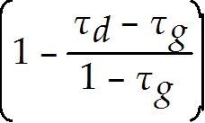

The term Pcum is:
A) the personal tax rate for capital gains.
B) the price per share after a dividend is paid.
C) the price per share before a dividend is paid.
D) the personal tax rate for dividend.

10) Consider the following equation:

Pcum - Pex = Div ×

The term τg is:
A) the personal tax rate for dividend.
B) the personal tax rate for capital gains.
C) the price per share before a dividend is paid.
D) the price per share after a dividend is paid.

17.5 Payout Versus Retention of Cash

Use the following information to answer the question(s) below.
d'Anconia Copper has $200 million in cash that it can use for a share repurchase. Suppose instead that d'Anconia Copper invests the funds in an account paying 5% interest for one year. Assume that the corporate tax rate is 35%, the individual capital gains rate is 15% and the individual rate on ordinary income is 30%.

1) The amount of additional cash that d'Anconia Copper will have at the end of the year net of corporate taxes is closest to:
A) $2.0 million
B) $5.5 million
C) $6.5 million
D) $7.0 million

2) Net of capital gains taxes, the amount the total value of d'Anconia Copper shares increase is closest to:
A) $5.5 million
B) $6.5 million
C) $7.0 million
D) $10.0 million

3) Net of ordinary income taxes, the amount that investors would have if they invested the $200 million on their own is closest to:
A) $5.5 million
B) $6.5 million
C) $7.0 million
D) $10.0 million
4) Suppose that d'Anconia Copper retained the $200 million in cash so that it would not need to raise new funds from outside investors for an expansion it has planned for next year. If it did raise new funds, it would have to pay issuance fees. Assuming that these fees can be expensed for corporate tax purposes, the amount that d'Anconia Copper needs to save in issuance fees to make retaining the cash beneficial for its investors is closest to:
A) $2.0 million
B) $5.5 million
C) $6.5 million
D) $7.0 million

5) Which of the following statements is FALSE?
A) In perfect capital markets, buying and selling securities is a zero-NPV transaction, so it should not affect firm value.
B) Making positive-NPV investments will create value for the firm's investors, whereas saving the cash or paying it out will not.
C) In perfect capital markets, if a firm invests excess cash flows in financial securities, the firm's choice of payout versus retention is irrelevant and does not affect the initial share price.
D) After adjusting for investor taxes, there remains a substantial tax advantage for the firm to retain excess cash.

6) Which of the following statements is FALSE?
A) A firm must balance the tax costs of holding cash with the potential benefits of having to raise external funds in the future.
B) Paying out excess cash through dividends or share repurchases can boost the stock price by reducing managers' ability and temptation to waste resources.
C) If there is a reasonable likelihood that future earnings will be insufficient to fund future positive-NPV investment opportunities, a firm may start accumulating cash to make up the difference.
D) According to the managerial entrenchment theory of payout policy, managers pay out cash only when pressured to do so by the firm's investors.

7) Which of the following formulas is INCORRECT?
A) τ*retain = 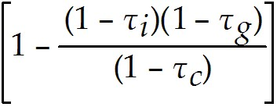
B) Pretain = 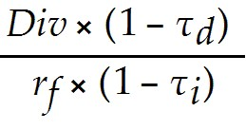
C) Pretain = Pcum × 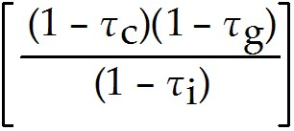
D) Pretain = Pcum × (1 - τ*retain)

8) Consider the following equation:

Pretain = Pcum × 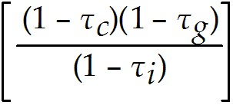

The term τi in this equation represents:
A) the corporation's tax rate on interest income.
B) the investor's tax rate on capital gains.
C) the investor's tax rate on interest income.
D) the investor's tax rate on cumulative dividends.

9) Consider the following equation:

Pretain = Pcum ×

The term Pretain in this equation represents:
A) the price of the stock if it retains and invests the cash.
B) the percentage of net income retained or reinvested back into the firm.
C) the percentage of net income paid out as a cash dividend.
D) the price of the stock if it retains cash to use in a share repurchase.

10) Consider the following equation:

Pretain = Pcum ×

The term τc in this equation represents:
A) the corporation's tax rate on interest income.
B) the investor's tax rate on interest income.
C) the investor's tax rate on cumulative dividends.
D) the investor's tax rate on capital gains.

17.6 Signaling with Payout Policy

1) Which of the following statements is FALSE?
A) Firms adjust dividends relatively infrequently, and dividends are much less volatile than earnings. This practice of maintaining relatively constant dividends is called dividend signaling.
B) When a firm increases its dividend, it sends a positive signal to investors that management expects to be able to afford the higher dividend for the foreseeable future.
C) The average size of the stock price reaction increases with the magnitude of the dividend change, and is larger for dividend cuts.
D) When managers cut the dividend, it may signal that they have given up hope that earnings will rebound in the near term and need to reduce the dividend to save cash.

2) Which of the following statements is FALSE?
A) If firms smooth dividends, the firm's dividend choice will contain information regarding management's expectations of future earnings.
B) Because of the increasing popularity of repurchases, firms cut dividends much more frequently than they increase them.
C) Announcing a share repurchase today does not necessarily represent a long-term commitment to repurchase shares.
D) While cutting the dividend is costly for managers in terms of their reputation and the reaction of investors, it is by no means as costly as failing to make debt payments.

3) Which of the following statements is FALSE?
A) Managers are much less committed to dividend payments than to share repurchases.
B) Share repurchases are a credible signal that the shares are under-priced, because if they are over-priced a share repurchase is costly for current shareholders.
C) While an increase of a firm's dividend may signal management's optimism regarding its future cash flows, it might also signal a lack of investment opportunities.
D) Managers will clearly be more likely to repurchase shares if they believe the stock to be under-valued.

Use the information for the question(s) below.

Rockwood Industries has 100 million shares outstanding, a current share price of $25, and no debt. Rockwood's management believes that the shares are under-priced, and that the true value is $30 per share. Rockwood plans to pay $250 million in cash to its shareholders by repurchasing shares. Management expects that very soon new information will come out that will cause investors to revise their opinion of the firm and agree with Rockwood's assessment of the firm's true value.

4) If Rockwood is able to repurchase shares prior to the market becoming aware of the new information regarding Rockwood's true value, then the number of shares outstanding following the repurchase is closest to:
A) 92 million
B) 10 million
C) 75 million
D) 90 million

5) Assume that Rockwood is not able to repurchase shares prior to the market becoming aware of the new information regarding Rockwood's true value. If Rockwood repurchases the shares following the release of the new information, then the number of shares outstanding following the repurchase is closest to:
A) 92 million
B) 90 million
C) 75 million
D) 10 million

6) Assume that Rockwood is able to repurchase shares prior to the market becoming aware of the new information regarding Rockwood's true value. After the repurchase, and following the release of the new information regarding the true value of Rockwood, the firm's share price is closest to:
A) $30.00
B) $31.50
C) $28.75
D) $30.60

7) Assume that Rockwood is not able to repurchase shares prior to the market becoming aware of the new information regarding Rockwood's true value. After the release of the new information regarding the true value of Rockwood, and following the repurchase, the firm's share price is closest to:
A) $30.00
B) $30.60
C) $28.75
D) $31.50

8) Calculate Rockwood's stock price following the market becoming aware of the new information regarding Rockwood's true value, if (1) Rockwood completed the repurchase prior to the market becoming aware of the information and (2) Rockwood completed the repurchase following the market becoming aware of the new information.

17.7 Stock Dividends, Splits, and Spin-offs

1) Taggart Transcontinental shares are currently trading at $200 per share. The split ratio needed to bring the stock price down to $80 is:
A) 2:1
B) 3:1
C) 2:5
D) 5:2

2) Which of the following statements is FALSE?
A) Stocks generally trade in lots of 1000 shares, and in any case do not trade in units less than one share.
B) Non-cash special dividends are commonly used to spin off assets or a subsidiary as a separate company.
C) The typical motivation for a stock split is to keep the share price in a range thought to be attractive to small investors.
D) If a company declares a 10% stock dividend, each shareholder will receive one new share of stock for every 10 shares already owned.

3) Which of the following statements is FALSE?
A) With a stock dividend, a firm does not pay out any cash to shareholders. As a result, the total market value of the firm's assets and liabilities, and therefore of its equity, is unchanged.
B) If the price of the stock falls too low, a company can engage in a reverse split and reduce the number of shares outstanding.
C) Stock dividends of 50% or higher are generally referred to as stock splits.
D) Rather than pay a dividend using cash or shares of its own stock, a firm can also distribute shares of a subsidiary in a transaction referred to as a off-shoot.

Use the information for the question(s) below.
Luther Industries currently has 5 million shares outstanding and its stock is currently trading at $40 per share.

4) Assuming Luther issues a 25% stock dividend, then Luther's new share price is closest to:
A) $24.00
B) $30.00
C) $16.00
D) $32.00

5) Assuming Luther issues a 5:2 stock split, then Luther's new share price is closest to:
A) $32.00
B) $16.00
C) $24.00
D) $30.00

6) Assuming Luther issues a 5:2 stock split, then the number of shares Luther will have outstanding following the split is closest to:
A) 25.0 million
B) 12.5 million
C) 2.0 million
D) 16.0 million

7) Delta Products has decided to spin-off one of its subsidiaries, Gamma Technologies. Each Delta shareholder will receive 0.125 shares of Gamma for each share of Delta they own. Delta's price is $35.00 cum-dividend and immediately after the spin-off Gamma Technologies was trading for $24.00 per share. In a perfect capital market, what would Delta Product's ex-dividend share price be after this transaction?

Corporate Finance, 4e, Global Edition (Berk / DeMarzo)
Chapter 18 Capital Budgeting and Valuation with Leverage

18.1 Overview of Key Concepts

1) Which of the following is NOT one of the simplifying assumptions made for the three main methods of capital budgeting?
A) The firm pays out all earnings as dividends.
B) The project has average risk.
C) Corporate taxes are the only market imperfection.
D) The firm's debt-equity ratio is constant.

2) Which of the following methods are used in capital budgeting decisions?
A) WACC method
B) APV method
C) FTE method
D) All of the above are used in capital budgeting decisions.

3) The assumption that the firm's debt-equity ratio is constant means:
A) the firm's cost of capital will not fluctuate when it accepts a new project.
B) corporate taxes are the only imperfection.
C) the risk of its debt and equity will change when it accepts a new project.
D) the firm adjusts its leverage to maintain a constant debt-equity ratio in terms of book value.

18.2 The Weighted Average Cost of Capital Method

1) Which of the following statements is FALSE?
A) Because the WACC incorporates the tax savings from debt, we can compute the levered value of an investment, which is its value including the benefit of interest tax shields given the firm's leverage policy, by discounting its future free cash flow using the WACC.
B) The WACC incorporates the benefit of the interest tax shield by using the firm's before-tax cost of capital for debt.
C) When the market risk of the project is similar to the average market risk of the firm's investments, then its cost of capital is equivalent to the cost of capital for a portfolio of all of the firm's securities; that is, the project's cost of capital is equal to the firm's weighted average cost of capital (WACC).
D) A project's cost of capital depends on its risk.

2) Which of the following statements is FALSE?
A) The WACC can be used throughout the firm as the company wide cost of capital for new investments that are of comparable risk to the rest of the firm and that will not alter the firm's debt-equity ratio.
B) A disadvantage of the WACC method is that you need to know how the firm's leverage policy is implemented to make the capital budgeting decision.
C) The intuition for the WACC method is that the firm's weighted average cost of capital represents the average return the firm must pay to its investors (both debt and equity holders) on an after-tax basis.
D) To be profitable, a project should generate an expected return of at least the firm's weighted average cost of capital.

3) Which of the following is NOT a step in the WACC valuation method?
A) Compute the value of the investment, including the tax benefit of leverage, by discounting the free cash flow of the investment using the WACC.
B) Compute the weighted average cost of capital.
C) Determine the free cash flow of the investment.
D) Adjust the WACC for the firm's current debt/equity ratio.

4) Consider the following equation:
rwacc = 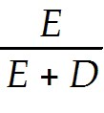rE + 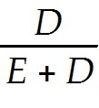rD(1 - τc)
the term E in this equation is:
A) the dollar amount of equity.
B) the dollar amount of debt.
C) the required rate of return on debt.
D) the required rate of return on equity.

5) Consider the following equation:
rwacc = rE + rD(1 - τc)
the term D in this equation is:
A) the dollar amount of debt.
B) the required rate of return on equity.
C) the required rate of return on debt.
D) the dollar amount of equity.

6) Consider the following equation:
rwacc = rE + rD(1 - τc)
the term rE in this equation is:
A) the after tax required rate of return on debt.
B) the required rate of return on debt.
C) the required rate of return on equity.
D) the dollar amount of equity.

7) Consider the following equation:
rwacc = rE + rD(1 - τc)
the term rD(1 - τc) in this equation is:
A) the required rate of return on debt.
B) the dollar amount of equity.
C) the after tax required rate of return on debt.
D) the required rate of return on equity.

8) Consider the following equation:
Dt = d × 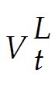
the term Dt in this equation is:
A) the firms target debt to value ratio.
B) the firms target debt to equity ratio.
C) the investment's debt capacity.
D) the dollar amount of debt outstanding at time t.

9) Consider the following equation:
Dt = d ×
the term d in this equation is:
A) the firms target debt to value ratio.
B) the dollar amount of debt outstanding at time t.
C) the firms target debt to equity ratio.
D) the investment's debt capacity.
Use the table for the question(s) below.

Consider the information for the following four firms:

Firm | Cash | Debt | Equity | rD | rE | τc
Eenie | 0 | 150 | 150 | 5% | 10% | 40%
Meenie | 0 | 250 | 750 | 6% | 12% | 35%
Minie | 25 | 175 | 325 | 6% | 11% | 35%
Moe | 50 | 350 | 150 | 7.50% | 15% | 30%

10) The weighted average cost of capital for "Eenie" is closest to:
A) 6.0%
B) 6.5%
C) 7.5%
D) 5.5%

11) The weighted average cost of capital for "Meenie" is closest to:
A) 10.5%
B) 7.4%
C) 10.0%
D) 8.8%

12) The weighted average cost of capital for "Minie" is closest to:
A) 9.50%
B) 8.75%
C) 6.75%
D) 8.25%

13) The weighted average cost of capital for "Moe" is closest to:
A) 10.00%
B) 7.75%
C) 8.25%
D) 8.50%

18.3 The Adjusted Present Value Method

1) Which of the following is NOT a step in the adjusted present value method?
A) Deducting costs arising from market imperfections
B) Calculating the unlevered value of the project
C) Calculating the after-tax WACC
D) Calculating the value of the interest tax shield

2) Which of the following statements is FALSE?
A) The firm's unlevered cost of capital is equal to its pre-tax weighted average cost of capital - that is, using the pre-tax cost of debt, rd, rather than its after-tax cost, rd (1 - τc ).
B) A firm's levered cost of capital is a weighted average of its equity and debt costs of capital.
C) When the firm maintains a target leverage ratio, its future interest tax shields have similar risk to the project's cash flows, so they should be discounted at the project's unlevered cost of capital.
D) The first step in the APV method is to calculate the value of free cash flows using the project's cost of capital if it were financed without leverage.

3) Which of the following statements is FALSE?
A) To determine the project's debt capacity for the interest tax shield calculation, we need to know the value of the project.
B) To compute the present value of the interest tax shield, we need to determine the appropriate cost of capital.
C) Because we don't value the tax shield separately, with the APV method we need to include the benefit of the tax shield in the discount rate as we do in the WACC method.
D) A target leverage ratio means that the firm adjusts its debt proportionally to the project's value or its cash flows.

4) Which of the following statements is FALSE?
A) The APV approach explicitly values the market imperfections and therefore allows managers to measure their contribution to value.
B) We need to know the debt level to compute the APV, but with a constant debt-equity ratio we need to know the project's value to compute the debt level.
C) The WACC method is more complicated than the APV method because we must compute two separate valuations: the unlevered project and the interest tax shield.
D) Implementing the APV approach with a constant debt-equity ratio requires solving for the project's debt and value simultaneously.

Use the table for the question(s) below.

Consider the information for the following four firms:

Firm | Cash | Debt | Equity | rD | rE | τc
Eenie | 0 | 150 | 150 | 5% | 10% | 40%
Meenie | 0 | 250 | 750 | 6% | 12% | 35%
Minie | 25 | 175 | 325 | 6% | 11% | 35%
Moe | 50 | 350 | 150 | 7.50% | 15% | 30%

5) The unlevered cost of capital for "Eenie" is closest to:
A) 6.0%
B) 5.5%
C) 7.5%
D) 6.5%

6) The unlevered cost of capital for "Moe" is closest to:
A) 8.25%
B) 7.75%
C) 8.50%
D) 10.00%

Use the information for the question(s) below.

Suppose Luther Industries is considering divesting one of its product lines. The product line is expected to generate free cash flows of $2 million per year, growing at a rate of 3% per year. Luther has an equity cost of capital of 10%, a debt cost of capital of 7%, a marginal tax rate of 35%, and a debt-equity ratio of 2. This product line is of average risk and Luther plans to maintain a constant debt-equity ratio.

7) Luther's Unlevered cost of capital is closest to:
A) 8.0%
B) 8.5%
C) 9.0%
D) 6.4%

8) The unlevered value of Luther's Product Line is closest to:
A) $25 million
B) $60 million
C) $45 million
D) $40 million

Use the information for the question(s) below.

Omicron Industries' Market Value Balance Sheet ($ Millions)
and Cost of Capital
Assets |  |  | Liabilities |  |  | Cost of Capital
Cash | 0 |  | Debt | 200 |  | Debt | 6%
Other Assets | 500 |  | Equity | 300 |  | Equity | 12%
 |  |  |  |  |  | τc | 35%

Omicron Industries New Project Free Cash Flows
Year | 0 | 1 | 2 | 3
Free Cash Flows | ($100) | $40 | $50 | $60

Assume that this new project is of average risk for Omicron and that the firm wants to hold constant its debt to equity ratio.

9) Omicron's Unlevered cost of capital is closest to:
A) 8.75%
B) 7.10%
C) 9.60%
D) 7.50%

10) The unlevered value of Omicron's new project is closest to:
A) $96
B) $124
C) $126
D) $25
11) The interest tax shield provided by Omicron's new project in year 1 is closest to:
A) $3.00
B) $1.05
C) $50.25
D) $17.60

18.4 The Flow-to-Equity Method

1) Which of the following statements is FALSE?
A) In the flow-to-equity valuation method, the cash flows to equity holders are then discounted using the weighted average cost of capital.
B) In the WACC and APV methods, we value a project based on its free cash flow, which is computed ignoring interest and debt payments.
C) In the flow-to-equity (FTE) valuation method, we explicitly calculate the free cash flow available to equity holders taking into account all payments to and from debt holders.
D) The first step in the FTE method is to determine the project's free cash flow to equity (FCFE).
2) Which of the following statements is FALSE?
A) The project's free cash flow to equity shows the expected amount of additional cash the firm will have available to pay dividends (or conduct share repurchases) each year.
B) The value of the project's FCFE should be identical to the NPV computed using the WACC and APV methods.
C) The value of the project's FCFE represents the gain to shareholders from the project.
D) Because interest payments are deducted before taxes, we adjust the firm's FCF by their before-tax cost.

3) Which of the following statements is FALSE?
A) If the debt-equity ratio changes over time, the risk of equity - and, therefore, its cost of capital - will change as well.
B) The FTE method can offer an advantage when calculating the value of equity for the entire firm, if the firm's capital structure is complex and the market values of other securities in the firm's capital structure are not known.
C) The FTE approach does not have the same disadvantage associated with the APV approach. We don't need to compute the project's debt capacity to determine interest and net borrowing before we can make the capital budgeting decision.
D) The WACC and APV methods compute the firm's enterprise value, so that a separate valuation of the other components of the firm's capital structure is needed to determine the value of equity.

4) Which of the following is NOT a step in valuation using the flow to equity method?
A) Determine the equity cost of capital, rE.
B) Compute the equity value, E, by discounting the free cash flow to equity using the
equity cost of capital.
C) Determine the free cash flow to equity of the investment.
D) Determine the before-tax cost of capital, rU.

Use the information for the question(s) below.

Suppose that Rose Industries is considering the acquisition of another firm in its industry for $100 million. The acquisition is expected to increase Rose's free cash flow by $5 million the first year, and this contribution is expected to grow at a rate of 3% every year there after. Rose currently maintains a debt to equity ratio of 1, its marginal tax rate is 40%, its cost of debt rD is 6%, and its cost of equity rE is 10%. Rose Industries will maintain a constant debt-equity ratio for the acquisition.

5) The Free Cash Flow to Equity (FCFE) for the acquisition in year 0 is closest to:
A) $5 million
B) $100 million
C) -$100 million
D) -$50 million

6) The Free Cash Flow-to-Equity (FCFE) for the acquisition in year 1 is closest to:
A) $4.7 million
B) $6.5 million
C) $8.3 million
D) $6.8 million

7) Describe the key steps in the flow to equity method for valuing a levered investment.

18.5 Project-Based Costs of Capital

Use the following information to answer the question(s) below.

Nielson Motors (NM) is a newly public firm with 25 million shares outstanding. You are doing a valuation analysis of Nielson and you estimate its free cash flow in the coming year to be $40 million. You expect the firm's free cash flows to grow by 4% per year in subsequent years. Because the firm has only been listed on the stock exchange for a short time, you do not have an accurate assessment of Nielson's equity beta. However, you do have the following data for another firm in the same industry:

Equity Beta | Debt Beta | Debt-Equity Ratio
1.8 | 0.4 | 1.5

Nielson has a much lower debt-equity ratio of .5, which is expected to remain stable, and Nielson's debt is risk free. Nielson's corporate tax rate is 40%, the risk-free rate is 5%, and the expected return on the market portfolio is 10%.

1) Nielson's estimated equity beta is closest to:
A) 0.95
B) 1.00
C) 1.25
D) 1.45

2) Nielson's equity cost of capital is closest to:
A) 11.3%
B) 12.2%
C) 14.0%
D) 14.4%

3) Nielson's share price is closest to:
A) $20.80
B) $24.40
C) $27.50
D) $31.20

4) Which of the following statements is FALSE?
A) In the real world, specific projects should differ only slightly from the average investment made by the firm.
B) We can estimate rU for a new project by looking at single-division firms that have similar business risks.
C) The project's equity cost of capital depends on its unlevered cost of capital, rU, and the debt-equity ratio of the incremental financing that will be put in place to support the project.
D) Projects may vary in the amount of leverage they will support - for example, acquisitions of real estate or capital equipment are often highly levered, whereas investments in intellectual property are not.

5) Which of the following statements is FALSE?
A) For capital budgeting purposes, the project's financing is the incremental financing that results if the firm takes on the project.
B) Projects with safer cash flows can support more debt before they increase the risk of financial distress for the firm.
C) If the positive free cash flow from a project will increase the firm's cash holdings, then this growth in cash is equivalent to a reduction in the firm's leverage.
D) The incremental financing of a project corresponds directly to the financing that is directly tied to the project.

6) Consider the following equation:
rwacc = rU - τcdrD

The term d in this equation is:
A) the project's unlevered cost of capital.
B) the project's dollar amount of debt.
C) the firm's unlevered cost of debt.
D) the project's debt to value ratio.
7) Consider the following equation:
rwacc = rU - τcdrD

The term rU in this equation is:
A) the firm's unlevered cost of debt.
B) the firm's cost of debt.
C) the project's unlevered cost of capital.
D) the project's debt to value ratio.

Use the information for the question(s) below.

The Aardvark Corporation is considering launching a new product and is trying to determine an appropriate discount rate for evaluating this new product. Aardvark has identified the following information for three single division firms that offer products similar to the one Aardvark is interested in launching:

Comparable Firm | Equity Cost of Capital | Debt Cost of Capital | Debt-to-Value Ratio
Anteater Enterprises | 12.50% | 6.50% | 50%
Armadillo Industries | 13% | 6.10% | 40%
Antelope Inc. | 14% | 7.10% | 60%

8) The unlevered cost of capital for Anteater Enterprises is closest to:
A) 10.1%
B) 9.5%
C) 9.9%
D) 10.3%
9) The unlevered cost of capital for Armadillo Industries is closest to:
A) 10.3%
B) 10.0%
C) 9.5%
D) 9.9%

10) The unlevered cost of capital for Antelope Incorporated is closest to:
A) 10.3%
B) 9.9%
C) 10.1%
D) 9.5%

18.6 APV with Other Leverage Policies

Use the following information to answer the question(s) below.

Rearden Metal is evaluating a project that requires an investment of $150 million today and provides a single cash flow of $180 million for sure one year from now. Rearden decides to use 100% debt financing for this investment. The risk-free rate is 5% and Rearden's corporate tax rate is 40%. Assume that the investment is fully depreciated at the end of the year.

1) The NPV of this project using the APV method is closest to:
A) $10 million
B) $13 million
C) $42 million
D) $71 million

2) The WACC for this project is closest to:
A) 3.0%
B) 5.0%
C) 7.0%
D) 8.2%

3) The NPV of this project using the WACC method is closest to:
A) $10 million
B) $13 million
C) $42 million
D) $71 million

4) Which of the following statements is FALSE?
A) Rather than set debt according to a target debt-equity ratio or interest coverage level, a firm may adjust its debt according to a fixed schedule that is known in advance.
B) When we relax the assumption of a constant debt-equity ratio, the equity cost of capital and WACC for a project will change over time as the debt-equity ratio changes.
C) When we relax the assumption of a constant debt-equity ratio, the APV and FTE methods are difficult to implement.
D) If a firm is using leverage to shield income from corporate taxes, then it will adjust its debt level so that its interest expenses grow with its earnings.

5) Which of the following statements is FALSE?
A) When we relax the assumption of a constant debt-equity ratio, the FTE method is relatively straightforward to use and is therefore the preferred method with alternative leverage policies.
B) When debt levels are set according to a fixed schedule, we can discount the predetermined interest tax shields using the debt cost of capital, rD.
C) With a constant interest coverage policy, the value of the interest tax shield is proportional to the project's unlevered value.
D) When the firm keeps its interest payments to a target fraction of its FCF, we say it has a constant interest coverage ratio.

6) Which of the following statements is FALSE?
A) As a general rule, the WACC method is the easiest to use when the firm will maintain a fixed debt-to-value ratio over the life of the investment.
B) The FTE method is typically used only in complicated settings for which the values of other securities in the firm's capital structure or the interest tax shield are themselves difficult to determine.
C) For alternative leverage policies, the FTE method is usually the most straightforward approach.
D) When used consistently, the WACC, APV, and FTE methods produce the same valuation for the investment.

Use the information for the question(s) below.

Aardvark Industries is considering a project that will generate the following free cash flows:

Year | 0 | 1 | 2 | 3
Free Cash Flows | ($200) | $100 | $80 | $60

You are also provided with the following market value balance sheet and information regarding Aardvark's cost of capital:

Assets |  |  | Liabilities |  |  | Cost of Capital
Cash | 0 |  | Debt | 400 |  | Debt | 7%
Other Assets | 1000 |  | Equity | 600 |  | Equity | 12%
 |  |  |  |  |  | τc | 35%

7) Aardvark's unlevered cost of equity is closest to:
A) 10.0%
B) 10.4%
C) 9.5%
D) 9.0%
8) The unlevered value of Aardvark's new project is closest to:
A) $205
B) $100
C) $164
D) $202

9) Suppose that to fund this new project, Aardvark borrows $120 with the principal to be paid in three equal installments at the end each year. The present value of Aardvark's interest tax shield is closest to:
A) $5.15
B) $5.00
C) $5.90
D) $5.25

10) Suppose that to fund this new project, Aardvark borrows $120 with the principal to be paid in three equal installments at the end each year. The levered value of Aardvark's new project is closest to:
A) $210.15
B) $207.35
C) $207.00
D) $210.50

18.7 Other Effects of Financing

Use the following information to answer the question(s) below.

Taggart Transcontinental is considering a $250 million investment to launch a new rail line. The project is expected to generate a free cash flow of $32 million per year, and its unlevered cost of capital is 8%. Taggart's marginal corporate tax rate is 35%.

1) Assuming that to fund the investment Taggart will take on $250 million in permanent debt and ignoring issuance costs, the NPV of Taggart's new rail line is closest to:
A) $195 million
B) $200 million
C) $235 million
D) $240 million

2) Assuming that to fund the investment Taggart will take on $250 million in permanent debt and assuming Taggart will incur a 2% (after-tax) underwriting fee on the new debt issue, the NPV of Taggart's new rail line is closest to:
A) $195 million
B) $200 million
C) $235 million
D) $240 million

3) Assume that to fund the investment Taggart will take on $150 million in permanent debt with the remainder of the investment funded by a cut in dividends. Assuming Taggart will incur a 2% (after-tax) underwriting fee on the new debt issue, the NPV of Taggart's new rail line is closest to:
A) $195 million
B) $200 million
C) $235 million
D) $240 million

4) Assume that to fund the investment Taggart will take on $150 million in permanent debt with the remainder of the investment funded through issuance of new equity. Assuming Taggart will incur a 2% (after-tax) underwriting fee on the new debt issue and a 5% underwriting fee on the issuance of new equity, the NPV of Taggart's new rail line is closest to:
A) $195 million
B) $200 million
C) $235 million
D) $240 million

5) Assume that to fund the investment Taggart will take on $150 million in permanent debt with the remainder of the investment funded through issuance of new equity. Assume Taggart will incur a 2% (after-tax) underwriting fee on the new debt issue and a 5% underwriting fee on the issuance of new equity. If management believes Taggart's current share price of $25 is $3 less than its true value, then the NPV of Taggart's new rail line is closest to:
A) $185 million
B) $195 million
C) $200 million
D) $235 million

6) Which of the following questions is FALSE?
A) With perfect capital markets, all securities are fairly priced and issuing securities is a zero-NPV transaction.
B) The fees associated with the financing of the project are independent of the project's required cash flows and should be ignored when calculating the NPV of the project.
C) When a firm borrows funds, a mispricing scenario arises if the interest rate charged differs from the rate that is appropriate given the actual risk of the loan.
D) The WACC, APV, and FTE methods determine the value of an investment incorporating the tax shields associated with leverage.

7) Which of the following questions is FALSE?
A) Sometimes management may believe that the securities they are issuing are priced at less than (or more than) their true value. If so, the NPV of the transaction, which is the difference between the actual money raised and the true value of the securities sold, should not be included in the value of the project.
B) An alternative method of incorporating financial distress and agency costs is to first value the project ignoring these costs, and then value the incremental cash flows associated with financial distress and agency problems separately.
C) When the debt level—and, therefore, the probability of financial distress—is high, the expected free cash flow will be reduced by the expected costs associated with financial distress and agency problems.
D) If the financing of the project involves an equity issue, and if management believes that the equity will sell at a price that is less than its true value, this mispricing is a cost of the project for the existing shareholders.

8) Luther Industries is considering borrowing $500 million to fund a new product line. Given investors' uncertainty regarding its prospects, Luther will pay a 7% interest rate on this loan. The firm's management knows, that the actual risk of the loan is extremely low and that the appropriate rate on the loan is 5%. Suppose the loan is for four years, with all principal being repaid in the fourth year. If Luther's marginal corporate tax rate is 35%, then the net effect of the loan on the value of the new product line is closest to:
A) $22 million
B) $34 million
C) $35 million
D) $24 million

9) Dusty Donuts has zero coupon debt with a face value of $10 million due in 3 years, and no other debt outstanding. The risk-free rate is 4%, but due to default risk the yield to maturity on the debt is 10%. Dusty's believes that in the event of default, 10% of the losses are attributable to bankruptcy and distress costs. Estimate the present value of the distress costs.
A) $138 million
B) $138 thousand
C) $1.38 million
D) $1.38 thousand

18.8 Advanced Topics in Capital Budgeting

Use the following information to answer the question(s) below.

Wyatt Oil is considering an investment in a new project with an unlevered cost of capital of 11%. Wyatt's marginal corporate tax rate is 35% and its debt cost of capital is 6%. The project has free cash flows of $25 million per year which are expected to decline by 3% per year.

1) If Wyatt adjusts its debt continuously to maintain a constant debt-equity ratio of 50%, then the appropriate WACC for this new project is closest to:
A) 7.5%
B) 8.6%
C) 10.3%
D) 10.8%

2) If Wyatt adjusts its debt once per year to maintain a constant debt-equity ratio of 50%, then the appropriate WACC for this new project is closest to:
A) 7.5%
B) 8.67%
C) 10.27%
D) 10.8%

3) If Wyatt adjusts its debt continuously to maintain a constant debt-equity ratio of 50%, then the value of this new project is closest to:
A) $188 million
B) $188.5 million
C) $320 million
D) $340 million

4) If Wyatt adjusts its debt once per year to maintain a constant debt-equity ratio of 50%, then the value of this new project is closest to:
A) $188 million
B) $188.5 million
C) $320 million
D) $340 million

Use the following information to answer the question(s) below.

Galt Industries is expected to generate free cash flows of $24 million per year. Galt has permanent debt of $80 million, a corporate tax rate of 40%, and an unlevered cost of capital of 12% and its cost of debt capital is 6%.

5) The value of Galt's equity using the APV method is closest to:
A) $150 million
B) $180 million
C) $230 million
D) $240 million

6) Galt's WACC is closest to:
A) 6.0%
B) 9.6%
C) 10.3%
D) 10.7%

7) The value of Galt's equity using the WACC method is closest to:
A) $150 million
B) $180 million
C) $230 million
D) $240 million

8) If Galt's debt cost of capital is 6%, then Galt's equity cost of capital is closest to:
A) 11.2%
B) 12.0%
C) 14.8%
D) 15.2%

9) Galt's free cash flow to equity (FCFE) is closest to:
A) $19.2 million
B) $20.4 million
C) $21.2 million
D) $24.0 million

10) Consider the following equation for the Project WACC with a fixed debt schedule:
rwacc = rU - dτc[rD + f(rU - rD)]

The term d in this equations represents:
A) a measure of the permanence of the debt level.
B) the annual adjustment percentage to the amount of debt.
C) the debt-to-value ratio.
D) the dollar amount of debt outstanding.

Corporate Finance, 4e, Global Edition (Berk / DeMarzo)
Chapter 20 Financial Options

20.1 Option Basics

1) Which of the following statements is FALSE?
A) A call option gives the owner the right to buy the asset.
B) A put option gives the owner the right to sell the asset.
C) A financial option contract gives the writer the right (but not the obligation) to purchase or sell an asset at a fixed price at some future date.
D) A stock option gives the holder the option to buy or sell a share of stock on or before a given date for a given price.

2) Which of the following statements is FALSE?
A) When a holder of an option enforces the agreement and buys or sells a share of stock at the agreed-upon price, he is exercising the option.
B) There are two kinds of options. European options allow their holders to exercise the option on any date up to and including a final date called the expiration date.
C) Because an option is a contract between two parties, for every owner of a financial option, there is also an option writer, the person who takes the other side of the contract.
D) The price at which the holder buys or sells the share of stock when the option is exercised is called the strike price or exercise price.

3) Which of the following statements is FALSE?
A) The option buyer, also called the option holder, holds the right to exercise the option and has a long position in the contract.
B) The market price of the option is also called the exercise price.
C) If the payoff from exercising an option immediately is positive, the option is said to be in-the-money.
D) As with other financial assets, options can be bought and sold. Standard stock options are traded on organized exchanges, while more specialized options are sold through dealers.

4) Which of the following statements is FALSE?
A) A holder would not exercise an in-the-money option.
B) The option seller, also called the option writer, sells (or writes) the option and has a short position in the contract.
C) Because the long side has the option to exercise, the short side has an obligation to fulfill the contract.
D) When the exercise price of an option is equal to the current price of the stock, the option is said to be at-the-money.

5) Which of the following statements is FALSE?
A) Options also allow investors to speculate, or place a bet on the direction in which they believe the market is likely to move.
B) Options where the strike price and the stock price are very far apart are referred to as deep in-the-money or deep out of-the-money.
C) Call options with strike prices above the current stock price are in-the-money, as are put options with strike prices below the current stock price.
D) European options allow their holders to exercise the option only on the expiration date—holders cannot exercise before the expiration date.

6) The writer of a call option has:
A) the obligation to sell a security for a given price.
B) the obligation to buy a security for a given price.
C) the right to sell a security for a given price.
D) the right to buy a security for a given price.

7) The holder of a put option has:
A) the obligation to sell a security for a given price.
B) the right to buy a security for a given price.
C) the right to sell a security for a given price.
D) the obligation to buy a security for a given price.

8) Using options to reduce risk is called:
A) speculation.
B) a naked position.
C) hedging.
D) a covered position.

9) Using options to place a bet on the direction in which you believe the market is likely to move is called:
A) speculation.
B) hedging.
C) a covered position.
D) a naked position.
Use the table for the question(s) below.

Consider the following information on options from the CBOE for Merck:
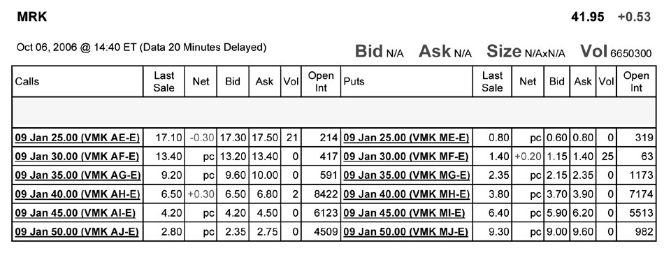

10) Assume you want to buy one option contract that with an exercise price closest to being at-the-money and that expires January 2009. The current price that you would have to pay for such a contract is:
A) $680
B) $380
C) $650
D) $420

11) The open interest for January 2009 put option that is closest to being at-the-money is:
A) 7174
B) 982
C) 319
D) 8422

12) How many of the January 2009 put options are in the money?
A) 1
B) 3
C) 2
D) 4

13) How many of the January 2009 call options are in the money?
A) 2
B) 4
C) 1
D) 3

14) The market price of an option is called the:
A) American premium.
B) European premium.
C) option premium.
D) exercising premium.

15) As the seller of an option, you are guaranteed to receive the:
A) exercise price.
B) strike price.
C) risk premium.
D) option premium.

Use the table for the question(s) below.

Consider the following information on options from the CBOE for Merck:

16) You have decided to sell (write) 5 January 2009 put options on Merck with an exercise price of $45 per share. How much money will you receive and are these contracts in or out of the money?

17) You have decided to buy 10 January 2009 call options on Merck with an exercise price of $45 per share. How much will this transaction cost you and are these contracts in or out of the money?

20.2 Option Payoffs at Expiration

1) The payoff to the holder of a call option is given by:
A) C = max(S - K, 0)
B) C = min(K, 0)
C) C = max(K - S, 0)
D) C = min(K - S, 0)

2) The payoff to the holder of a put option is given by:
A) P = max(K - S, 0)
B) P= max(S - K, 0)
C) P = min(S - K, 0)
D) P = max(K, 0)

Use the figure for the question(s) below.
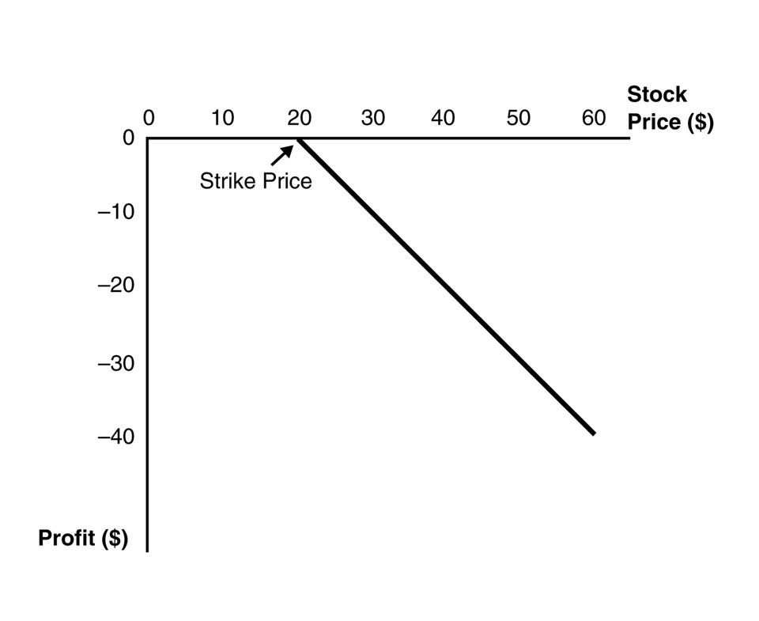
3) This graph depicts the payoffs of:
A) a short position in a put option at expiration.
B) a short position in a call option at expiration.
C) a long position in a put option at expiration.
D) a long position in a call option at expiration.

Use the figure for the question(s) below.
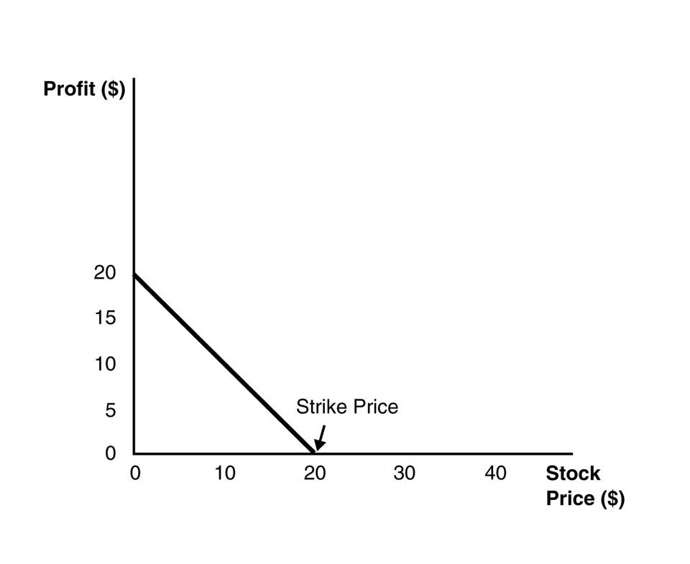
4) This graph depicts the payoffs of:
A) a long position in a put option at expiration.
B) a short position in a call option at expiration.
C) a short position in a put option at expiration.
D) a long position in a call option at expiration.

5) An option strategy in which you hold a long position in both a put and a call option with the same strike price is called:
A) a strangle.
B) portfolio insurance.
C) a butterfly spread.
D) a straddle.
6) Which of the following statements is FALSE?
A) Because a short position in an option is the other side of a long position, the profits from a short position in an option are just the negative of the profits of a long position.
B) The deeper out-of-the-money the put option is, the less negative its beta, and the higher is its expected return.
C) Although payouts on a long position in an option contract are never negative, the profit from purchasing an option and holding it to expiration could well be negative because the payout at expiration might be less than the initial cost of the option.
D) The put position has a higher return in states with low stock prices; that is, if the stock has a positive beta, the put has a negative beta.

7) You pay $3.25 for a call option on Luther Industries that expires in three months with a strike price of $40.00. Three months later, at expiration, Luther Industries is trading at $41.00 per share. Your profit per share on this transaction is closest to:
A) -$1.00
B) $1.00
C) -$2.25
D) $2.25

8) Graph the payoff at expiration of a short position in a put option with a strike price of $20.

9) You are long both a put option and a call option on Rockwood stock with the same expiration date. The exercise price of the call option is $40 and the exercise price of the put option is $30. Graph the payoff of the combination of options at expiration.

20.3 Put-Call Parity

1) Consider the following equation:
C = P + S - PV(K) - PV(Div)

In this equation the term S refers to:
A) the payoff of a zero coupon bond.
B) the strike price of the option.
C) the value of the call option.
D) the stock's current price.

2) Consider the following equation:
C = P + S - PV(K) - PV(Div)

In this equation the term C refers to:
A) the value of the call option.
B) the stock's current price.
C) the payoff of a zero coupon bond.
D) the strike price of the option.

3) Consider the following equation:
C = P + S - PV(K) - PV(Div)

In this equation the term K refers to:
A) the value of the call option.
B) the strike price of the option.
C) the price of a zero coupon bond.
D) the stock's current price.

4) Luther Industries is currently trading for $27 per share. The stock pays no dividends. A one-year European put option on Luther with a strike price of $30 is currently trading for $2.60. If the risk-free interest rate is 6% per year, then the price of a one-year European call option on Luther with a strike price of $30 will be closest to:
A) $1.30
B) $7.10
C) $2.60
D) $1.95

Use the table for the question(s) below.

Consider the following information on options from the CBOE for Merck:

5) Assume it is now January of 2007 and the current risk-free interest rate is 1%. Using Put-Call Parity and the January 30 option (ask price), estimate the relative contribution of the near-term dividends to the value of Merck's stock.
A) $4.89
B) $2.35
C) $4.30
D) $20.19

6) Rose Industries is currently trading for $47 per share. The stock pays no dividends. A one-year European call option on Luther with a strike price of $45 is currently trading for $7.45. If the risk-free interest rate is 6% per year, then calculate the price of a one-year European put option on Luther with a strike price of $45.

20.4 Factors Affecting Option Prices

1) Suppose that Nielson Motors stock is trading for $50 per share and that Nielson pays no dividends. What is the maximum possible price for a call option on Nielson Motors?
A) $0
B) $20
C) $50
D) infinite

2) Suppose that Nielson Motors stock is trading for $50 per share and that Nielson pays no dividends. What is the minimum possible price for an American put option on Nielson Motors with a strike price of $70?
A) $0
B) $20
C) $50
D) infinite

3) Which of the following will NOT increase the value of a put option?
A) An increase in the time to maturity
B) A decrease in the stock price
C) A decrease in the stock's volatility
D) An increase in the exercise price

4) Which of the following statements is FALSE?
A) Put-call parity gives the price of a European call option in terms of the price of a European put, the underlying stock, and a zero-coupon bond.
B) For a given strike price, the value of a call option is higher if the current price of the stock is higher, as there is a greater likelihood the option will end up in-the-money.
C) The value of an otherwise identical call option is higher if the strike price the holder must pay to buy the stock is higher.
D) Because a put is the right to sell the stock, puts with a lower strike price are less valuable.

5) Which of the following statements is FALSE?
A) The intrinsic value of an option is the value it would have if it expired immediately.
B) A European option cannot be worth less than its American counterpart.
C) Put options increase in value as the stock price falls.
D) A put option cannot be worth more than its strike price.

6) Which of the following statements is FALSE?
A) Because an American option cannot be worth less than its intrinsic value, it cannot have a negative time value.
B) An American option with a later exercise date cannot be worth less than an otherwise identical American option with an earlier exercise date.
C) The value of an option generally decreases with the volatility of the stock.
D) The intrinsic value is the amount by which the option is currently in-the money or 0 if the option is out-of-the-money.
7) KD Industries stock is currently trading at $32 per share. Consider a put option on KD stock with a strike price of $30. The intrinsic value of this put option is:
A) $0
B) -$2
C) $2
D) $30

8) KD Industries stock is currently trading at $32 per share. Consider a put option on KD stock with a strike price of $30. The maximum value of this put option is:
A) $0
B) $32
C) $30
D) $2

20.5 Exercising Options Early

Use the following information to answer the question(s) below.

Consider an American put option on Rearden Metal stock with a strike price of $60 and one year to expiration. Assume that Rearden pays no dividends, its stock is currently trading at $15 per share, and the one year interest rate is 5%. Also assume that it is optimal to exercise this put option early.

1) The price of a one-year American put option on Rearden Metal with a strike price of $70 per share is closest to:
A) $45
B) $50
C) $55
D) $60

2) The maximum value of a one-year American call option on Rearden Metal with a strike price of $60 per share is closest to:
A) $0
B) $1.84
C) $2.48
D) $2.86

3) Consider the following equation:
C = S - K + dis(K) + P

In this equation, S - K tells us:
A) the market value of the option.
B) the time value of the option.
C) the option spread.
D) the intrinsic value of the option.

4) Consider the following equation:
C = S - K + dis(K) + P - PV(Div)

In this equation, dis(K) + P - PV(Div) tells us:
A) the market value of the option.
B) the difference in the price of an American option over a European option because of dividend capture.
C) the intrinsic value of the option.
D) the time value of the option.

5) Which of the following statements is FALSE?
A) An American call on a non-dividend-paying stock has the same price as its European counterpart.
B) The price of any call option on a non-dividend-paying stock always exceeds its intrinsic value.
C) It is never optimal to exercise a call option on a dividend-paying stock early—you are always better off just selling the option.
D) If present value of the dividend payment is large enough, the time value of a European call option can be negative, implying that its price could be less than its intrinsic value.

6) Describe the conditions when it would be optimal to exercise an American Call and an American Put option prior to their expiration.

20.6 Options and Corporate Finance

Use the following information to answer the question(s) below.

Galt Industries is trading for $20 per share and has 25 million shares outstanding. Galt Industries has a debt-equity ratio of 0.4 and its debt is zero coupon debt with a ten year maturity and a yield to maturity of 8%.

1) In describing Galt's equity as a call option, the maturity of this option is:
A) 5 years
B) 10 years
C) 20 years
D) infinite

2) In describing Galt's equity as a call option, the market value of the assets underlying the call option is:
A) $200 million
B) $300 million
C) $500 million
D) $700 million

3) In describing Galt's equity as a call option, the strike price of the call option is:
A) $200 million
B) $300 million
C) $500 million
D) $700 million

4) In describing Galt's debt as a put option, the strike price of the put option is:
A) $200 million
B) $300 million
C) $500 million
D) $700 million

5) Which of the following best describes Galt's debt using a put option?
A) Long $200 million in risk free debt and Short a put option on the firm's assets with a $200 strike price
B) Short $200 million in risk free debt and Long a put option on the firm's assets with a $200 strike price
C) Long $200 million in risk free debt and Short a put option on the firm's assets with a $700 strike price
D) Short $200 million in risk free debt and Long a put option on the firm's assets with a $700 strike price

6) Which of the following best describes Galt's debt using a call option?
A) Long $700 million in the firm's assets and Short a call option with a $700 strike price
B) Short $700 million in the firm's assets and Long a call option with a $700 strike price
C) Long $700 million in the firm's assets and Short a call option with a $200 strike price
D) Short $700 million in the firm's assets and Long a call option with a $200 strike price

7) As of June of 2016, Facebook (FB) had no debt. Suppose the firm's managers consider issuing zero-coupon debt with a face value of $231 billion due in January of 2019 (19 months) and using the proceeds to pay a special dividend. FB has 2.31 billion shares outstanding, with a market price (June, 2016) of $116.62. The risk-free rate over this horizon is 0.25%.
There is a call option trading on FB with a strike price of $100 and a price of $29.24. What is the implied credit spread of Facebook's proposed debt issue assuming perfect capital markets?
A) 8.89%
B) 8.64%
C) 19.74%
D) Cannot be determined from information given.

8) Which of the following statements is FALSE?
A) The option price is more sensitive to changes in volatility for at-the-money options than it is for in-the-money options.
B) A share of stock can be thought of as a put option on the assets of the firm with a strike price equal to the value of debt outstanding.
C) In the context of corporate finance, equity is at-the-money when a firm is close to bankruptcy.
D) Because the price of equity is increasing with the volatility of the firm's assets, equity holders benefit from a zero-NPV project that increases the volatility of the firm's assets.

9) Which of the following statements is FALSE?
A) If the value of the firm's assets exceeds the required debt payment, debt holders are fully repaid.
B) Another way to view corporate debt: as a portfolio of riskless debt and a short position in a call option on the firm's assets with a strike price equal to the required debt payment.
C) Viewing debt as an option portfolio is useful as it provides insight into how credit spreads for risky debt are determined.
D) You can think of the debt holders as owning the firm and having sold a call option with a strike price equal to the required debt payment.

10) A credit default swap is essentially a:
A) put option on the firm's assets.
B) call option on the firm's assets.
C) put option on the firm's debt.
D) call option on the firm's debt.

11) With a(n) ________, the buyer pays a premium to the seller and receives a payment from the seller to make up for the loss if the underlying bond defaults.
A) equity option swap
B) credit default swap
C) risk-free swap
D) interest rate swap

